A

PROJECT REPORT ON

MICRO PROJECT ON

# << “computer security threat ”>>

(COMPUTER NETWORKING(4340703))

SUBMITTED BY

#YOUR NAME#

**To**

**#YOUR COLLAGE NANE & INFORMATION #**

## Index

|  |  |
| --- | --- |
| **Sr. No.** | **Topic Name** |
| **1** | Introduction the Project. |
| **2** | Hardware and Software requirements (If any) |
| **3** | Sample Code/Architecture (If any) |
| **4** | Screenshots of System and Output (If any) |
| **5** | Application of your Project |
| **6** | Advantages and Disadvantages of Project |
| **7** | Summary of Project |
| **8** | References |

**Introduction to Project**

Computer security threats are malicious acts that seek to damage, steal, or disrupt data and systems. With the growing reliance on technology, the need to understand and mitigate these threats has become critical.

This project aims to identify various types of threats in the digital world, explain how they work, and explore methods of prevention and protection.

This project "Analysis and Awareness of Computer Security Threats," explores various forms of security threats, demonstrates how they can compromise digital systems, and educates users about protective measures.

Through well-structured sections and multimedia resources, this system aims to enhance cybersecurity awareness among users, especially students and professionals.

### Requirements of Project

* **Hardware Requirements:**
* Computer or laptop with internet connectivity
* Minimum 4GB RAM and 500MB storage
* Internet connectivity for accessing video resources
* **Software Requirements:**
* Web browser (Chrome, Firefox)
* HTML/CSS support for documentation
* Code editor (VS Code, Sublime Text) for development
* **Knowledge Requirements:**
* Basic understanding of cybersecurity concepts
* Awareness of internet browsing and file handling
* Optional: Basic knowledge of HTML/CSS for customization

### Architecture/Code of Project

### <!DOCTYPE html>

### <html lang="en">

### <head>

### <meta charset="UTF-8" />

### <meta name="viewport" content="width=device-width, initial-scale=1.0"/>

### <title>Computer Security Threats</title>

### <style>

### * {

### box-sizing: border-box;

### margin: 0;

### padding: 0;

### }

### body {

### font-family: 'Segoe UI', Tahoma, Geneva, Verdana, sans-serif;

### background: linear-gradient(135deg, #1b1f3b, #2c3e50);

### color: #f0f0f0;

### line-height: 1.6;

### }

### nav {

### background: rgba(0, 0, 0, 0.4);

### padding: 15px 10px;

### display: flex;

### flex-wrap: wrap;

### justify-content: center;

### gap: 10px;

### position: sticky;

### top: 0;

### z-index: 1000;

### backdrop-filter: blur(10px);

### }

### nav a {

### color: #ffffffcc;

### text-decoration: none;

### padding: 10px 18px;

### border-radius: 30px;

### transition: all 0.3s ease;

### font-weight: 500;

### }

### nav a:hover {

### background-color: rgba(255, 255, 255, 0.1);

### color: #ffe600;

### }

### nav a.active {

### background-color: #ffe600;

### color: #000;

### font-weight: bold;

### }

### .container {

### max-width: 1100px;

### margin: 40px auto;

### padding: 30px;

### background-color: #2e3a59;

### border-radius: 15px;

### box-shadow: 0 10px 30px rgba(0, 0, 0, 0.3);

### }

### .highlight-box {

### background: rgba(255, 255, 255, 0.05);

### border: 2px solid #ffe600;

### padding: 25px;

### border-radius: 15px;

### box-shadow: 0 0 20px #ffe60066;

### text-align: center;

### margin-bottom: 25px;

### transition: transform 0.3s ease, box-shadow 0.3s ease;

### }

### .highlight-box:hover {

### transform: scale(1.02);

### box-shadow: 0 0 25px #ffe600aa;

### }

### h1 {

### color: #ffe600;

### font-size: 2.5em;

### animation: glow 1.5s ease-in-out infinite alternate;

### }

### @keyframes glow {

### from {

### text-shadow: 0 0 10px #ffe60080, 0 0 20px #ffe60040;

### }

### to {

### text-shadow: 0 0 20px #ffe600cc, 0 0 30px #ffe60099;

### }

### }

### .definition {

### font-size: 1.1rem;

### color: #e0e0e0;

### margin-bottom: 30px;

### text-align: center;

### max-width: 800px;

### margin-inline: auto;

### }

### h2 {

### text-align: center;

### color: #ffd700;

### margin-bottom: 20px;

### text-shadow: 0 0 10px #ffe60044;

### }

### .img-section {

### text-align: center;

### margin-bottom: 30px;

### }

### .img-section img {

### width: 100%;

### max-width: 700px;

### border-radius: 12px;

### box-shadow: 0 5px 15px rgba(0, 0, 0, 0.4);

### }

### .card-grid {

### display: grid;

### grid-template-columns: repeat(auto-fit, minmax(280px, 1fr));

### gap: 25px;

### margin-top: 30px;

### }

### .card {

### background: #3c4a6b;

### padding: 20px;

### border-radius: 12px;

### box-shadow: 0 6px 18px rgba(0, 0, 0, 0.2);

### transition: transform 0.3s ease, box-shadow 0.3s ease;

### }

### .card:hover {

### transform: translateY(-5px);

### box-shadow: 0 0 20px #ffe60055;

### }

### .card h3 {

### color: #ffe600;

### margin-bottom: 10px;

### text-shadow: 0 0 8px #ffe60066;

### }

### .card p, .card ul {

### color: #ddd;

### font-size: 0.95rem;

### }

### .card ul {

### padding-left: 20px;

### list-style-type: disc;

### }

### */* Next Button with Effects */*

### .next-button {

### position: relative;

### display: inline-block;

### margin: 40px auto 0;

### background: #ffe600;

### color: #000;

### padding: 14px 28px;

### border-radius: 50px;

### text-decoration: none;

### font-weight: bold;

### text-align: center;

### overflow: hidden;

### transition: all 0.3s ease;

### box-shadow: 0 4px 12px rgba(0, 0, 0, 0.3);

### }

### .next-button:hover {

### background-color: #ffcf00;

### box-shadow: 0 0 15px #ffe600, 0 0 25px #ffe60080;

### }

### .next-button::after {

### content: '';

### position: absolute;

### left: 50%;

### top: 50%;

### width: 0;

### height: 0;

### background: rgba(255, 255, 255, 0.4);

### border-radius: 50%;

### transform: translate(-50%, -50%);

### transition: width 0.4s ease, height 0.4s ease;

### z-index: 0;

### }

### .next-button:active::after {

### width: 200%;

### height: 500%;

### }

### .next-button span {

### position: relative;

### z-index: 1;

### }

### @media (max-width: 600px) {

### nav {

### flex-direction: column;

### }

### .container {

### padding: 20px;

### }

### .next-button {

### padding: 12px 20px;

### }

### }

### </style>

### </head>

### <body>

### <nav>

### <a href="index.html" class="active">Home</a>

### <a href="malware.html">Malware</a>

### <a href="viruses.html">Viruses</a>

### <a href="insiders.html">Insiders</a>

### <a href="Criminal_Organization.html">Criminal Org.</a>

### <a href="intruder.html">Intruder</a>

### <a href="terrorist_activity.html">Terrorist Activity</a>

### <a href="videos.html">Videos</a>

### <a href="about.html">About</a>

### </nav>

### <div class="container">

### <div class="highlight-box">

### <h1>Computer Security Threats</h1>

### </div>

### <p class="definition">

### A computer security threat is any potential danger or malicious activity that can compromise the confidentiality, integrity, or availability of data, systems, or networks. These threats can originate from both physical and digital sources, such as cybercriminals, system vulnerabilities, or even natural disasters.

### </p>

### <h2>Types of Threats</h2>

### <div class="img-section">

### <img src="https://d2ds8yldqp7gxv.cloudfront.net/Blog+Explanatory+Images/Top+10+Cyber+Security+Threats+2.webp" alt="Computer Security Threats">

### </div>

### <div class="card-grid">

### <div class="card">

### <h3>Physical Threats</h3>

### <p>

### Physical threats involve environmental or human actions that can damage computer hardware or systems, resulting in data loss, outages, or device failure. Examples include fire, theft, flooding, and vandalism.

### </p>

### </div>

### <div class="card">

### <h3>Non-Physical Threats</h3>

### <p>

### These threats do not cause physical harm but aim to compromise system functionality, steal sensitive information, or disrupt operations. Examples include hacking, phishing, and malicious software.

### </p>

### </div>

### <div class="card">

### <h3>Common Non-Physical Threats</h3>

### <ul>

### <li>Malware</li>

### <li>Viruses, Worms, and Trojans</li>

### <li>Intruders and Hackers</li>

### <li>Malicious Insiders</li>

### <li>Criminal Organizations</li>

### <li>Terrorist Activities</li>

### </ul>

### </div>

### </div>

### <div style="text-align: center;">

### <a href="malware.html" class="next-button"><span>Next Page ➡</span></a>

### </div>

### </div>

### </body>

### </html>

### Screenshots of working project/Output

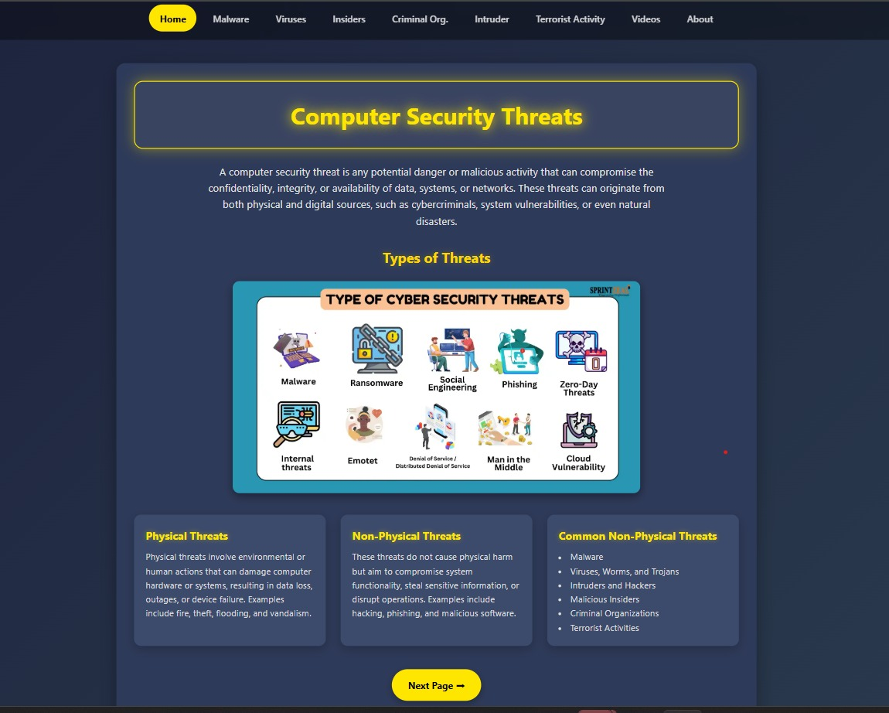Put screenshot of your project here

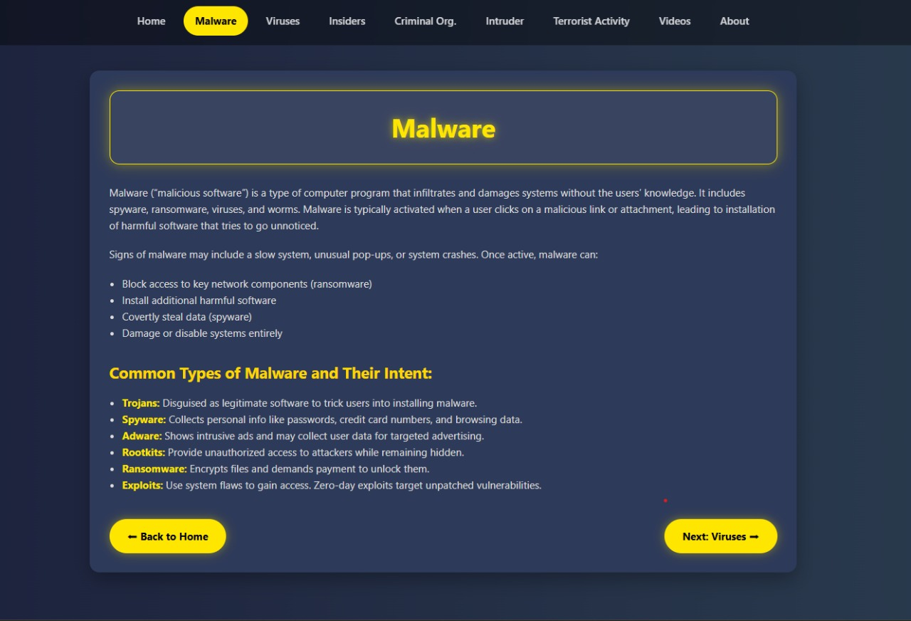

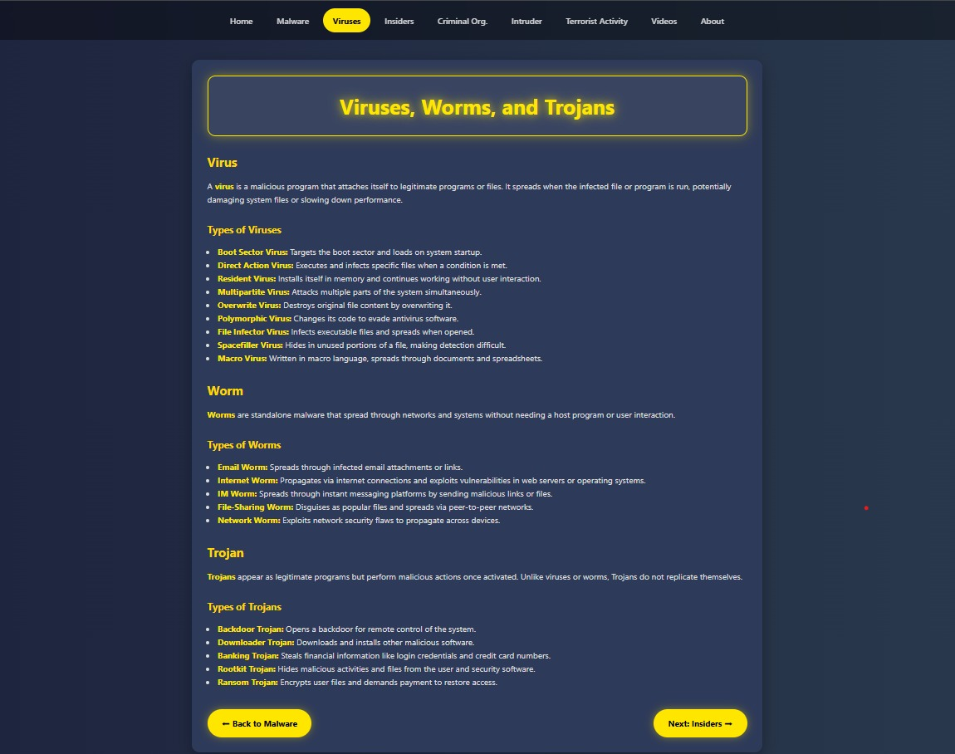

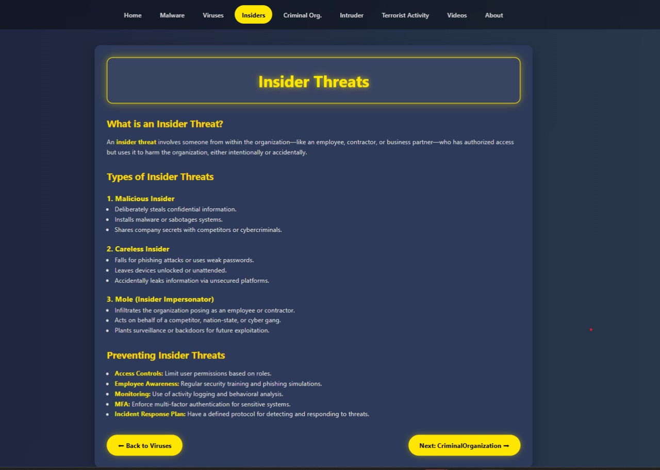

### 

### 

### 

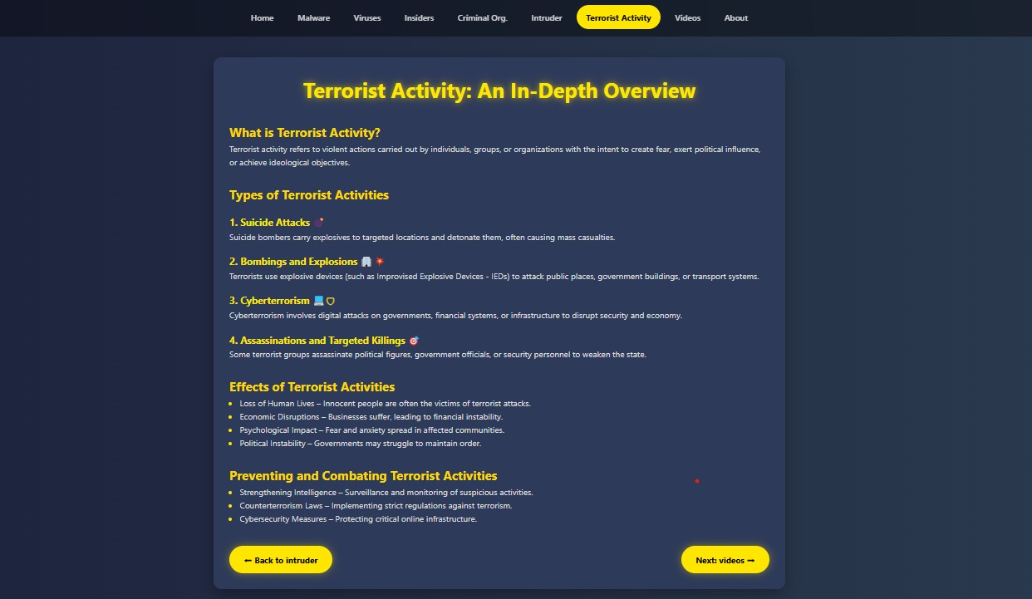

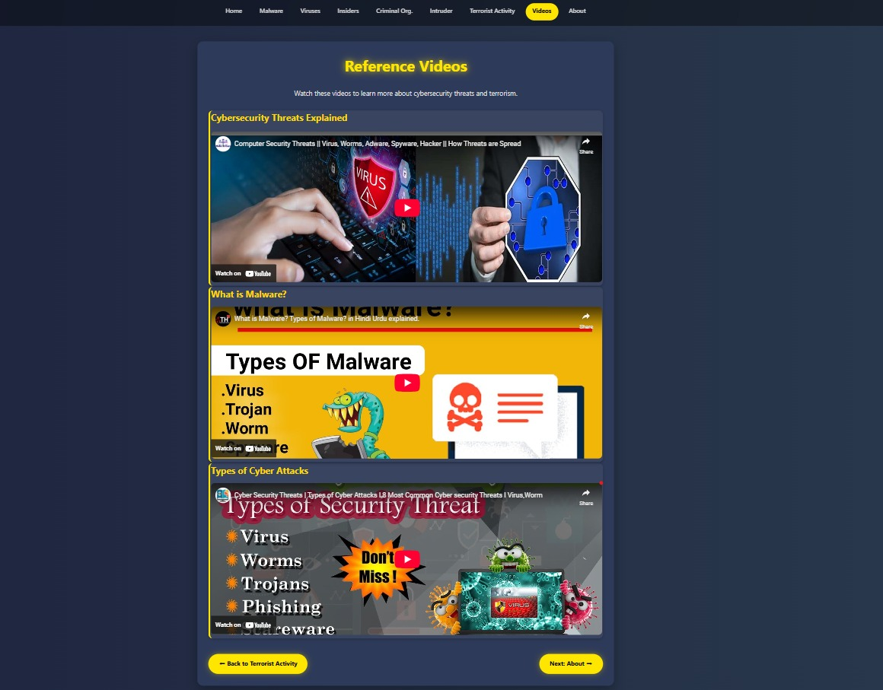

### #ADD YOUR ABOUNT PAGE SCREEN SHORT#

### Application of your system

* **Educational Use:**
* This project serves as a resourceful guide for students and educators in IT, cybersecurity, and computer science disciplines. It introduces threats in a simplified, engaging format with reference videos and interactive elements.
* **Government and Security Agencies**
  + Awareness about terrorism-related cyber activities and intrusion techniques is essential. This system briefly outlines such threats and informs users on how to respond or report them.
* **Awareness Campaigns:**
* It helps in spreading awareness about online threats and safe practices.
* **Corporate Training:**
* Organizations can use this system to train employees about potential security threats and promote best practices such as strong password use, recognizing phishing attacks, and safe internet browsing.
* **Security Assessment:**
* Provides an overview of risks, aiding in the risk assessment process.
* **General Public Awareness:**
* Anyone who uses digital devices can benefit from learning about malware, insider threats, and preventive measures to avoid becoming a victim of cybercrime.

### Advantages and Disadvantages of your system

* Advantages:
* Enhances awareness of cyber threats
* User-friendly Design
* Easy-to-understand visual explanations (videos, descriptions)
* Promotes proactive security practices
* Useful for academic and training purposes
* Disadvantages:
* Cannot provide real-time protection
* No Real-Time Monitoring
* Limited Depth
* May not cover every evolving threat
* Lacks interaction or dynamic threat simulation

**Summary**

This project on computer security threats provides a comprehensive overview of different types of digital dangers that users face today. It educates users about malware, viruses, insider threats, intruders, terrorist activities, and more.

With its user-friendly layout and informative content, it serves as a foundation for building stronger cybersecurity knowledge and practices.

**References**

GOOGLE:

<https://www.techtarget.com/searchsecurity/feature/Top-10-types-of-information-security-threats-for-IT-teams>

YOUTUBE:

<https://youtu.be/W46HD9XkLLE?si=LcpmI3UKQbgjQgVG>

<https://youtu.be/cNVwkLo1Snw?si=X8gzCWAFrYfINEYz>